Designation | Nb | Price
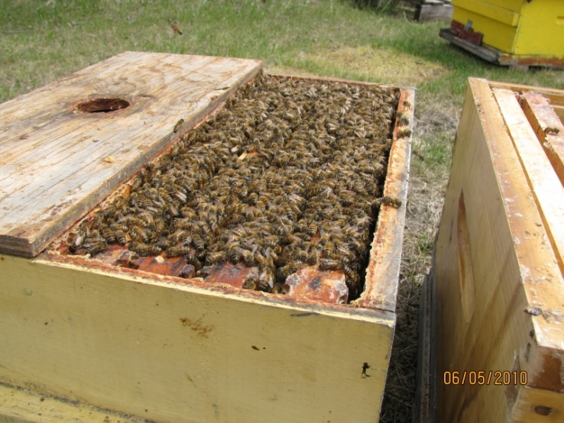  Nucs for sale | 100 | 4 frame nucs  Available mid may minimum of 3 frames of brood and 1 frame of food.  We raise our own queens.  185$ each
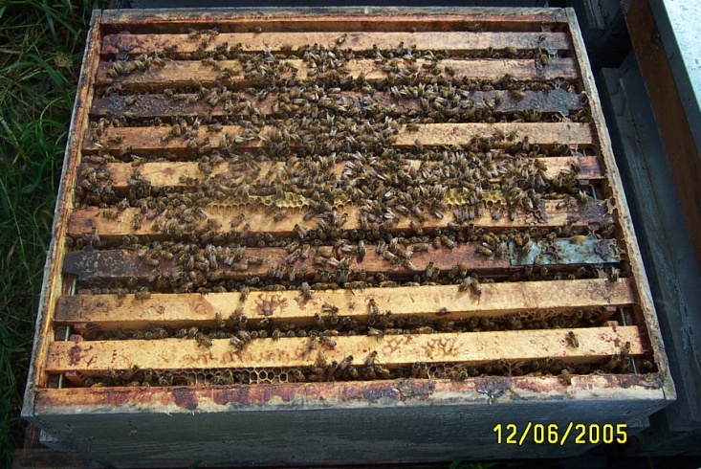  Single hive for sale | 100 | 100 Single hive available mid may, minimum of 6 frame of brood.  Comes with an inner cover, screnned bottom board and a telescopic lid.  We raise our own queens  250$ each
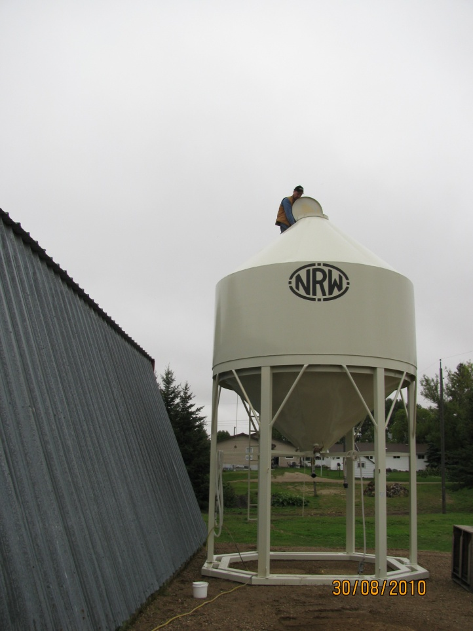  Syrup tank | 1 | Custom built syrup tank with 6 foot clearance to use gravity for transfering syrup on to the trailor.  3 inch valve + 2 inch valve +  3/8 valve on the side to push compressed air into the syrup to mix the water with the syrup.  Holds a full semi load.  7000$
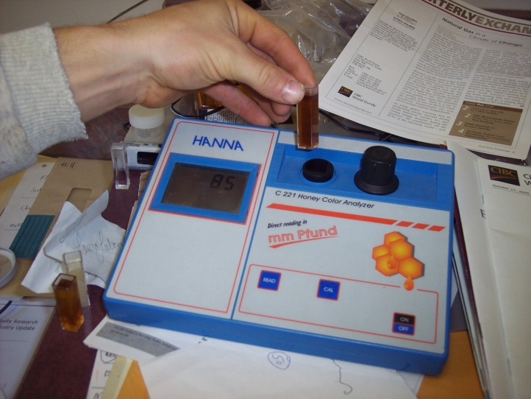  Color grader | 1 | 400$  Comes with tons of sampling container and glycol. Many replacement caps too
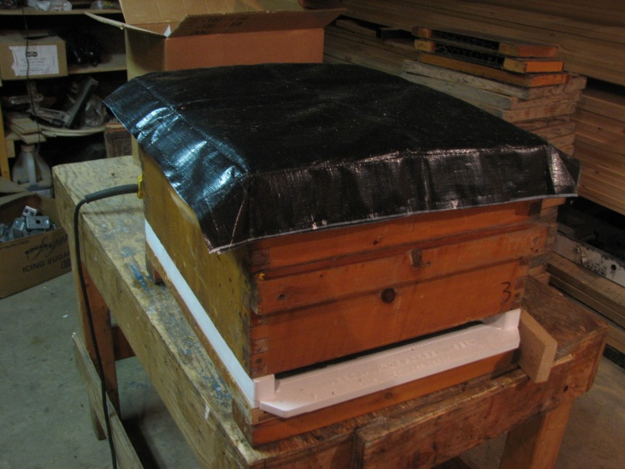  Insulated cushion for spring management | 1000 | 7.25$ each  Keep your cluster warm during a cold spring. Telescopic lids fits exactly on top of the cushion allowing you to put some patties on top of the frames.  Bee tight and air tight when telescopic lids in place.
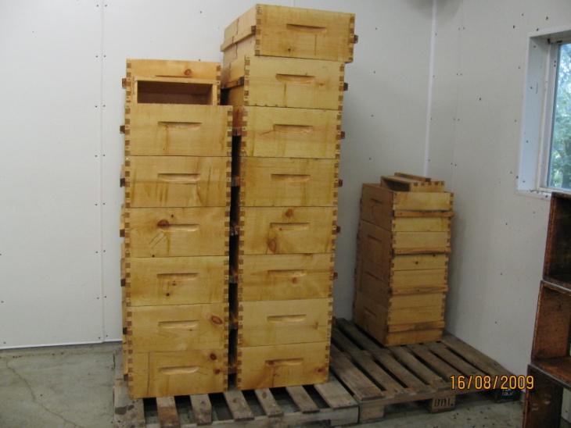  Supers  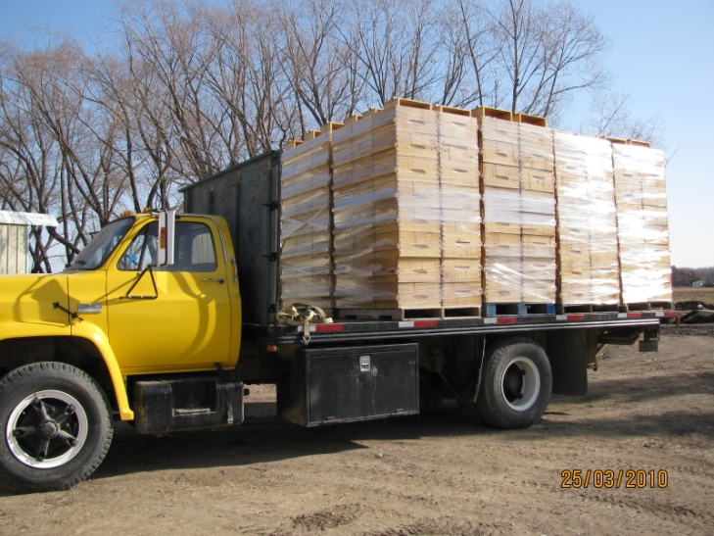 | 2.000 units | 60$ each  Boxes are dipped boxes with cleats on the side and regular built-in handles, 8 frames nice condition and light color frames all drawn.  Canadian standard dimensions  Boxes come on regular pallets with 5 level high so 20 per pallet and we charge 10$ per pallet.
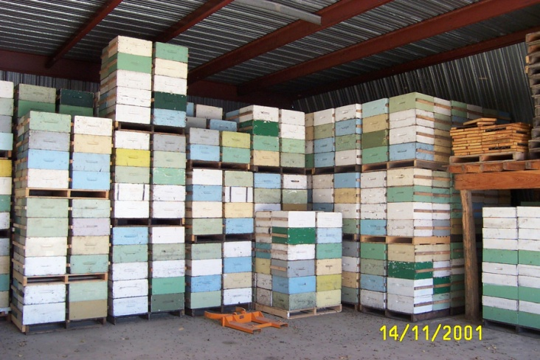  Painted supers | 600 supers | Those boxes are 55$ each. They are painted boxes, with cleats on the front and back and built in regular handles on the left and right, 8 frames per box nicely drawn and light color. All boxes are Canadian standard dimensions  Boxes come on regular pallets with 5 level high so 20 per pallet and we charge 10$ per pallet.
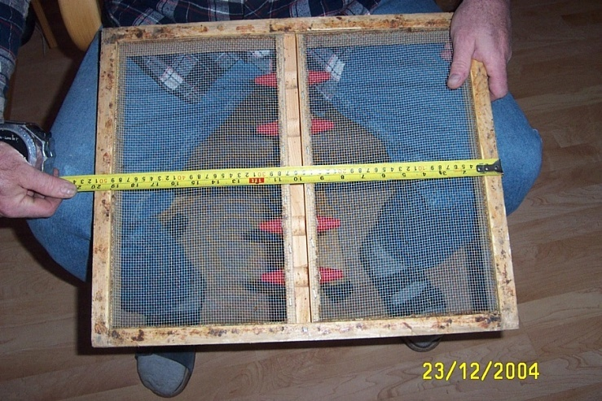  Bee escape boards | 250 | Screened escape boads  15$ each
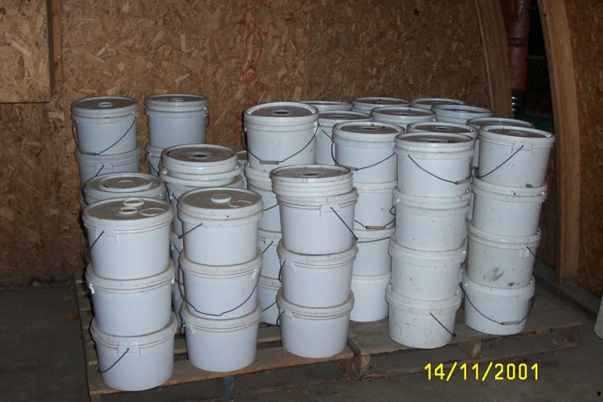  Feeder pails | 500 | Very nice condition feeder pails  5$
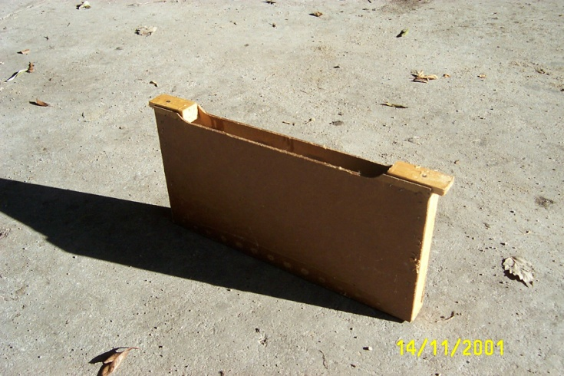  Frame feeder | 1000 | Wax dipped Frame feeder  6$ each
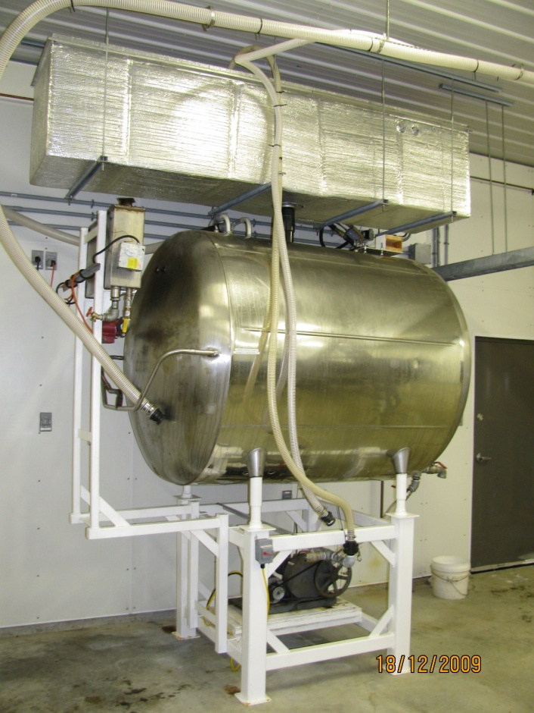 |  | This unique dehumidifier is used right after the extraction in case you still have high moisture honey, it takes the honey in the main tank, pumps it into a heat exchanger and the water is separated from the honey and flows in a bucket just beside the machine, you can dry your honey once extracted so no interruption in your honey crop.  This machine is very unique, one of a kind and very efficient, capacity 50 liters of water per day,  8000$
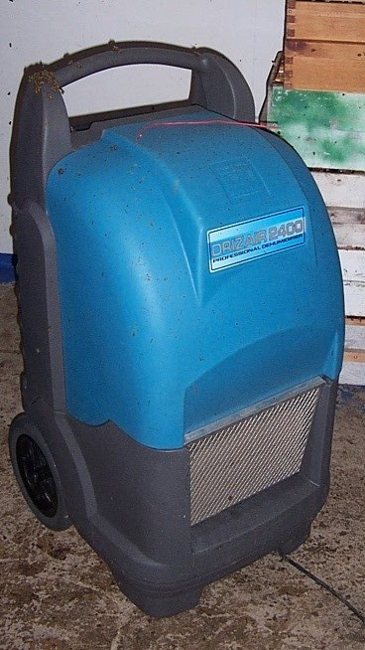  Drizair dehumidifier | 2 | High capacity industrial dehumidifier 60 liters of water per day, 2 units for sale  2800$
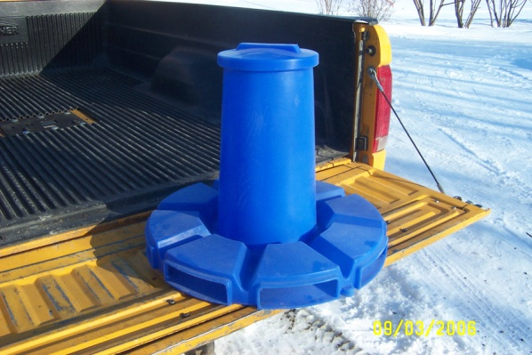  Pollen dispenser | 10 | 60$
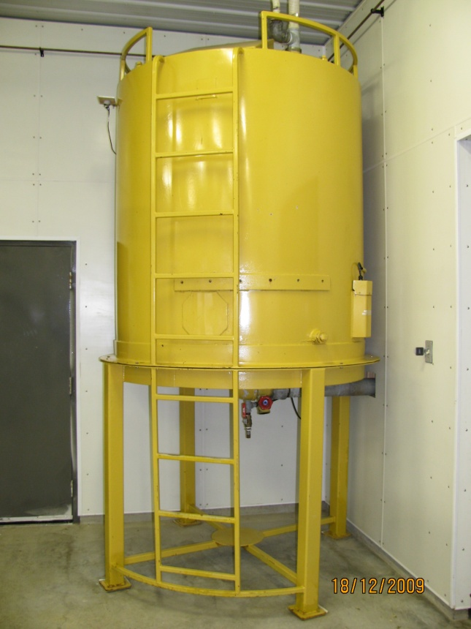  Double jacketed stainless main tank | 1 | 11 drums capacity double jacketed main tank, equipped with a stainless ladder on the inside and a steel ladder on the outside. 2 X 3000 watts heater on the sides that heat up the water contained inside the jacket and everywhere around the honey.  Keep your honey warm during your extraction days.  5000$
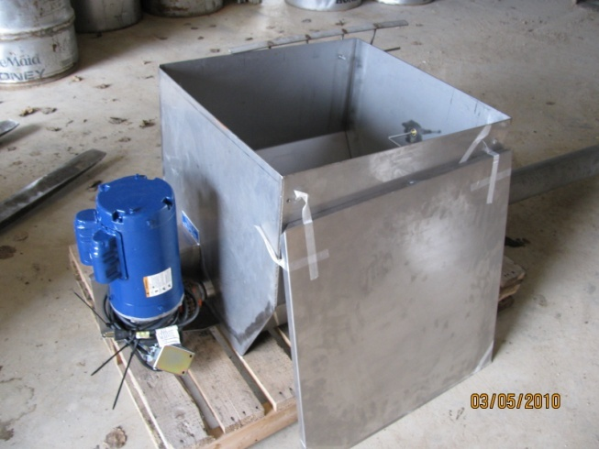  Cowen honey collection system equipped with a 4 inch auger | 1 | This sump sits under your uncapper and collect the cappings and the honey from the extractor.  A 4 inch and 10 foot long auger goes right to the extractor on the other side of the uncapper and collect the honey coming out of the extractor  Pump is connected on the front of the sump.  1500$
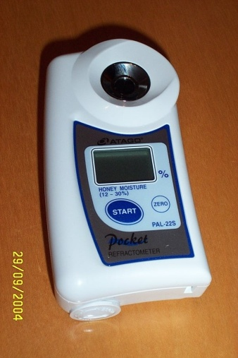  honey refractometer | 1 | 250$
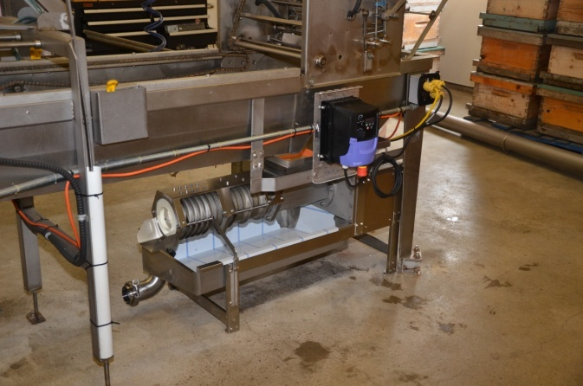  Wax press | 1 | Brand new Wax press model 350  This model replaced our spin float 2 years ago, it separates the honey from the wax. This machine comes from Finland and is made by Paradise honey Ltd  350 lbs of wax per day  12000$
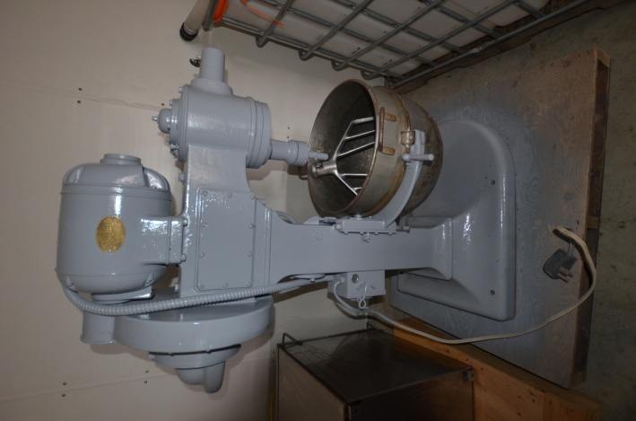  Dough Mixer | 1 | That dough mixer is very usefull when its time to make pollen patties  1500$
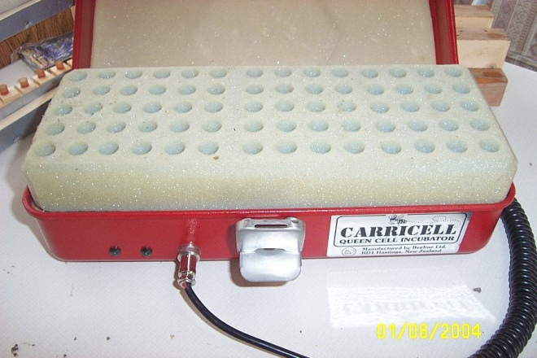  Portable incubator | 1 | Caricell portable incubator  400$
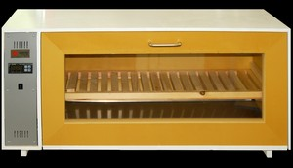  Swienty incubator | 1 | This incubator is very recent and has been modified to fit 280 cells instead of 130 cells.  It is in great shape and very efficient, works like a charm.  Professional quality.  2000$
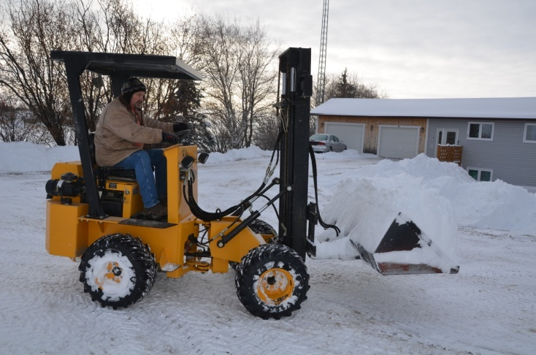  Swinger forklift | 1 | 2007 Great shape hummer bee, mint condition, indestructible, affordable and reliable machine  36000$
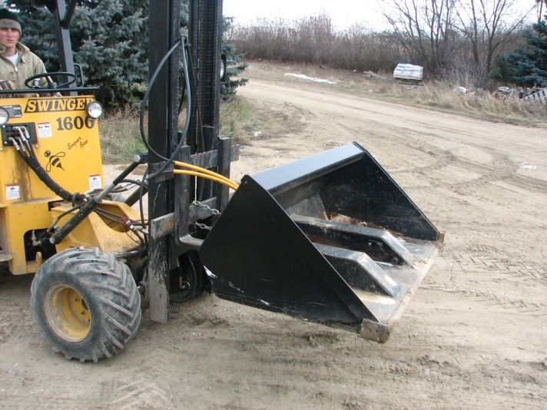  Bucket for the swinger | 1 | 2800$
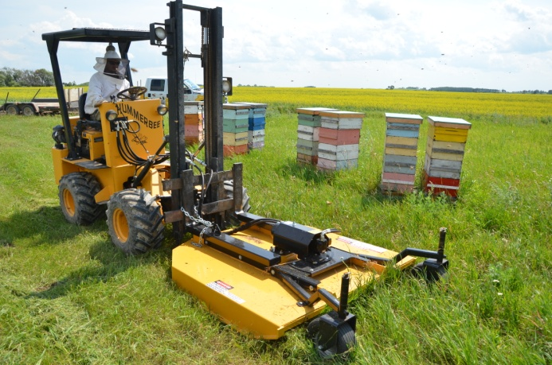  Hummer bee trimmer | 1 | Very powerfull trimmer to clean your bee yard in an instant, high cutting capacity. Connected to the side shift of the machine  3500$
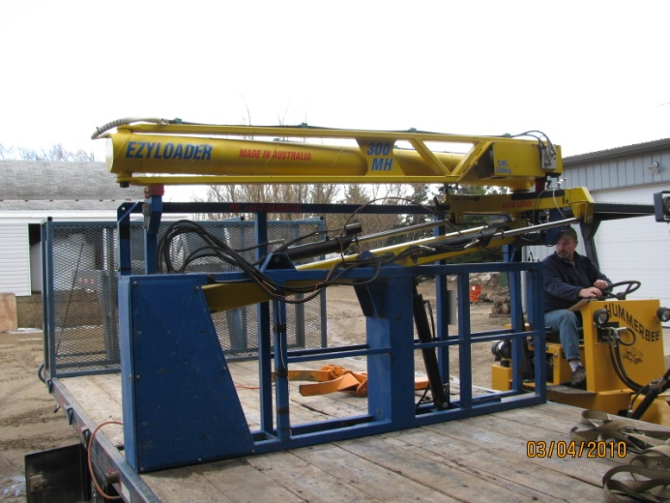  Billet easy loader 300 kgs | 1 | 300 kgs model  Nice shape, works like a charm  16000$
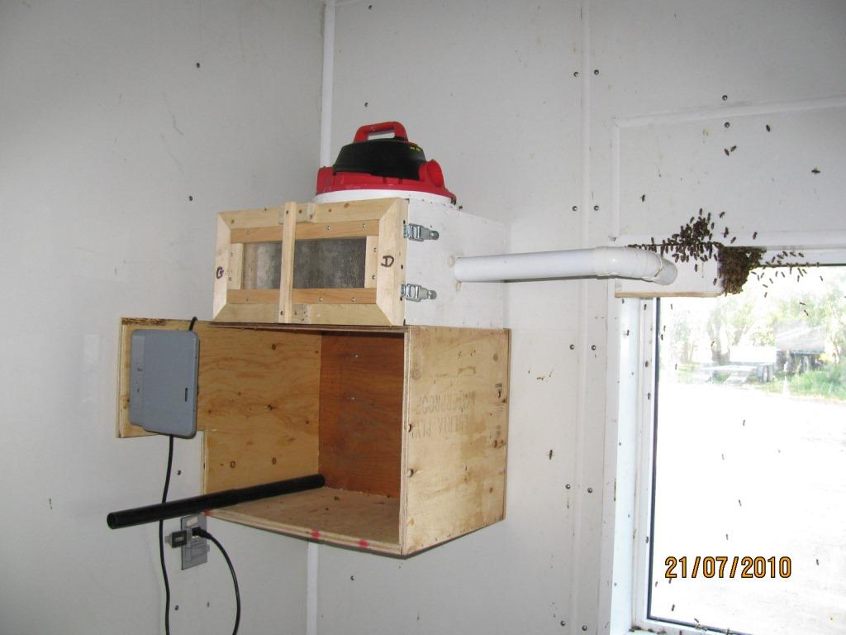  Bee vacuum | 1 | Bee Vacuum  We use this vacuum in the hot room.  Bees are collected close to the window inside the vacuum and transferred on a regular basis in original hives. Comes with 3 extractable collection baskets that fits exactly inside the vacuum.  Safe on the bees and very useful. Vacuum starts every 5 minutes. Every single baskets contains a maximum of 5 pounds of bees. Comes with a timer.  1.000$
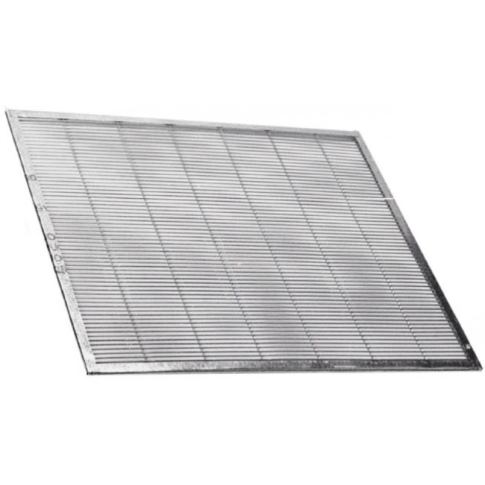  Queen excluder | 1000 | 7$ each, very good condition, cleaned up every season
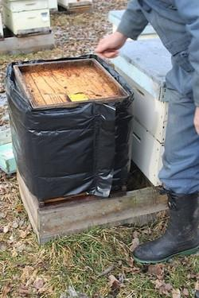  Individual hive wrap | 250 | Hive wrap for each individual hives, fits a regular size hive. we use them to keep our double nuc hives warm. Very efficient in our cold spring, colonies are building up way faster.  They were custom designed just for us. Insulation is R30  This picture is a bee cozy wrap. I can send you the picture of our wraps, they look different and fits much better the hive.  12$ each
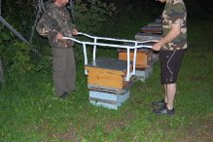  Hive grabber | 1 | Custom designed for us, this grabber fits exactly on both side of a hive, cranks securely into the handle. No more backache to move the bees.  250$
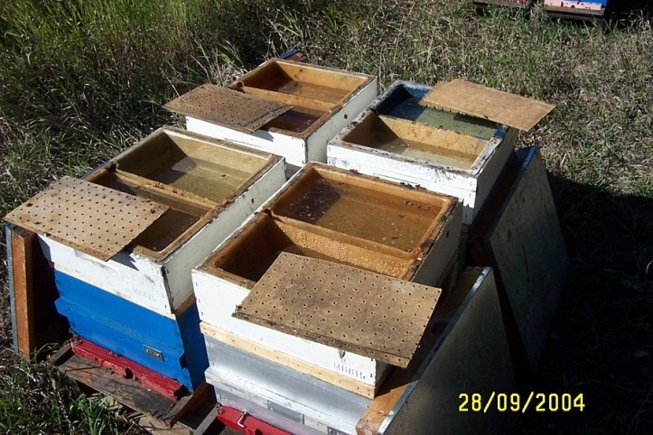  Hive top feeder | 400 | Hive top feeders  3$ each
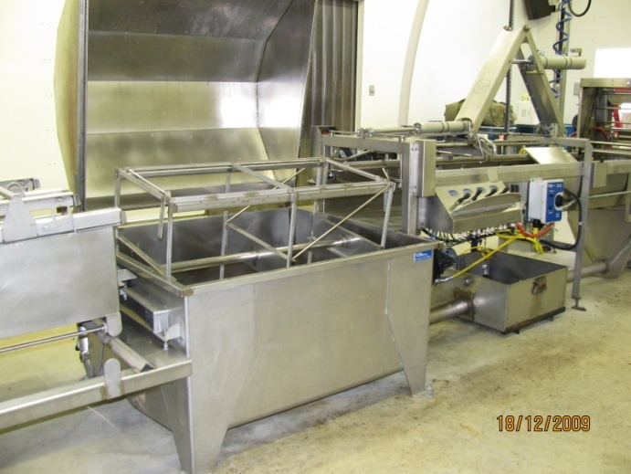  60 frame Cowen extractor air ram | 1 | 32000$  Really good condition, not even a dent, will work perfectly for another 30 years
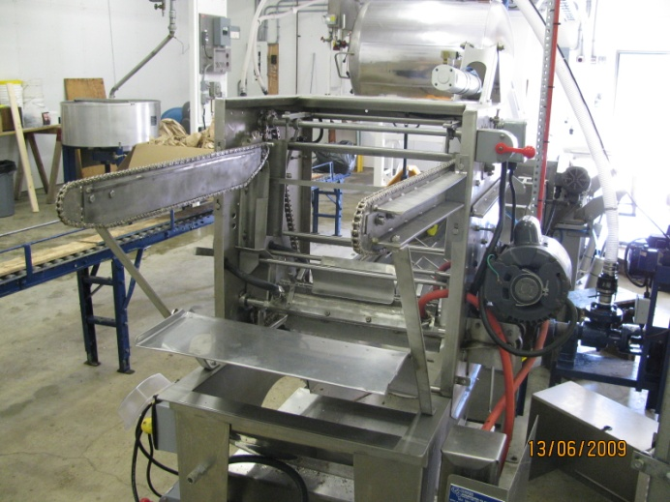  Cowen Jumbo Uncapper | 1 | 10000$  Original Jumbo model with prolonged arms that can accomodate 2 boxes or 20 frames
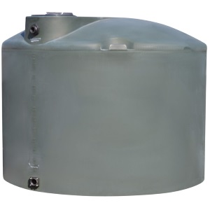 | 1 | 5000 l plastic tank  500$
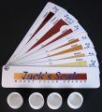  Jack scale | 1 | Jack scale  20$
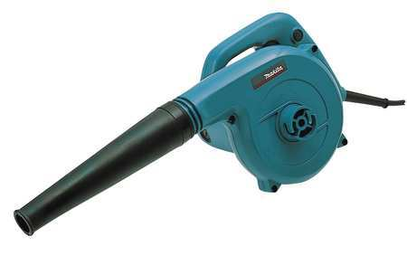  Makita bee blower | 1 | 250$
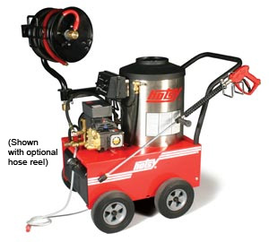  Hotsy pressure washer | 1 | 2500 PSI Hotsy pressure washer  Only 2 years on this unit, comes with a hoose dispenser very usefull.  4000$
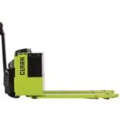  Clark electric pallet jack EWP 30 | 1 | Very recent machine. brand new battery  3500$
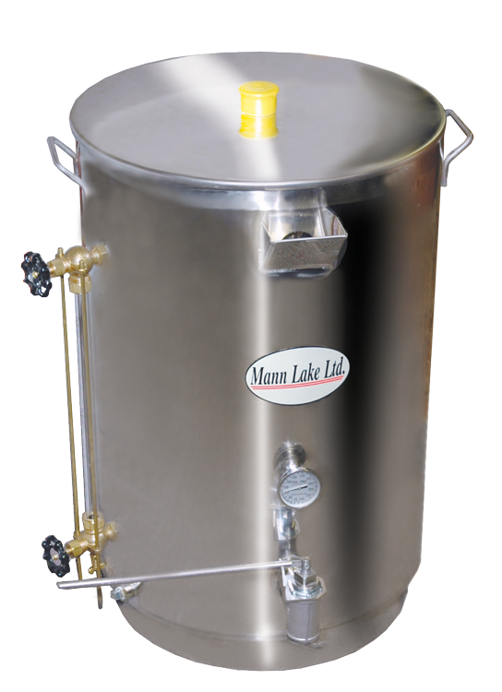  Man lake bottling tank 30 gallons | 1 | 1.200$
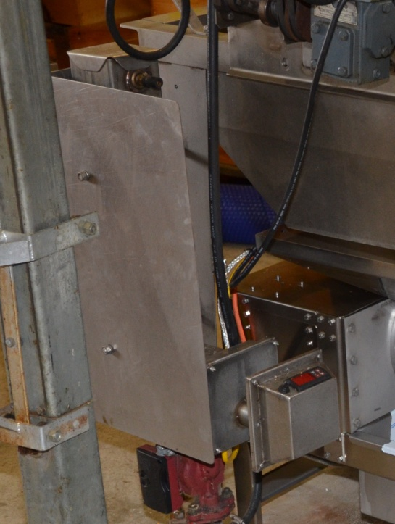  Boiler unit for the uncapper | 1 | 1.200$
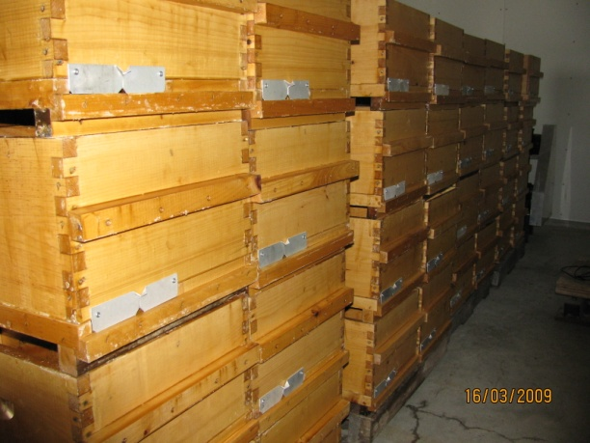  Double nuc chamber | 250 | Double nuc hive with separated entrances, 4 frames on each side.  Comes with an inner cover and a telescopic lid.  Most of them are new  35$ each
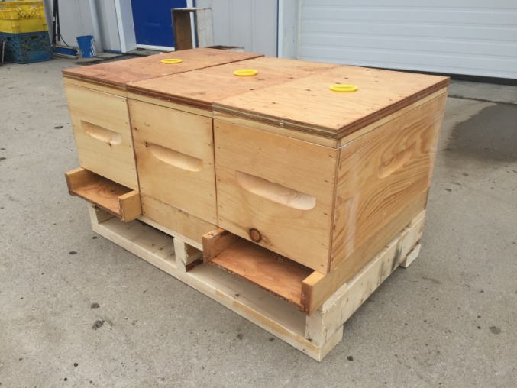  6 frames nucs | 100 | 6 frame nucs, only 2 years old.  Comes with a slopped bottom board and an inner cover + entrance reducers.  Each one is 20$, no frame inside  6 framers sit on a pallet. pallets are 10$ each
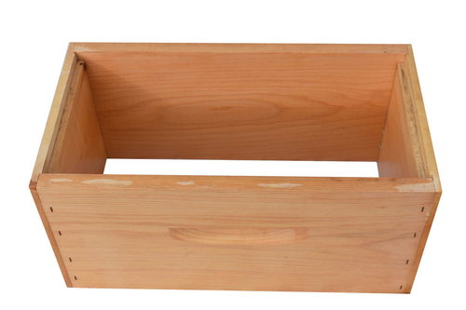  Supers for 6 framers | 200 | We have boxes with 5 frame inside that we use for the honey flow only on the above 6 framers colonies, they are equipped with 5 nice frames and drawn combs  25$ each
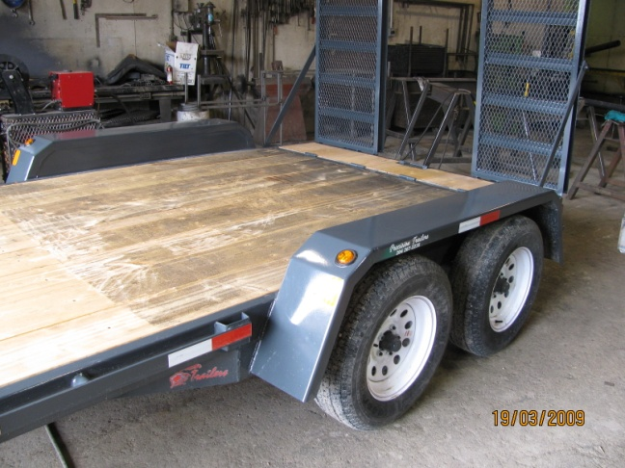  Swinger trailor | 1 | 16 foot trailor for the hummer bee  3.500$
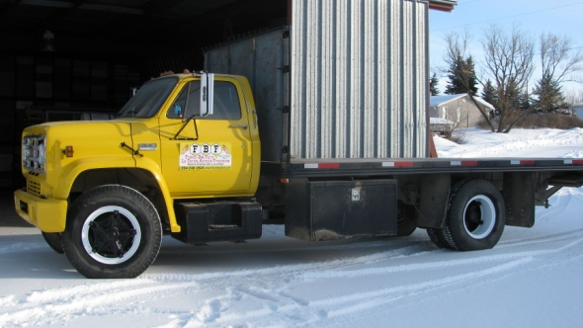 | 1 | 1977 GMC SIERRA 3 tons truck 18 foot deck works great  9.000$
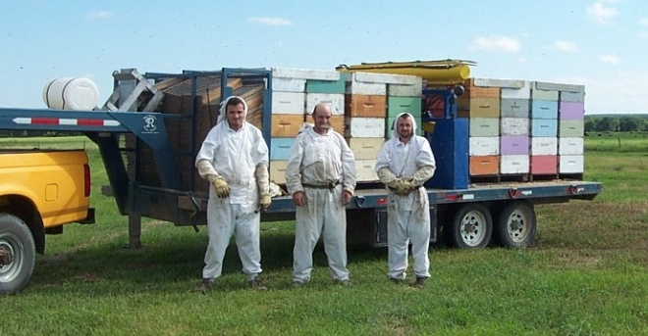 | 1 | 20 FOOT GOSSE NECK TRAILOR  7.000$  Flat deck no ramp tool box on the side
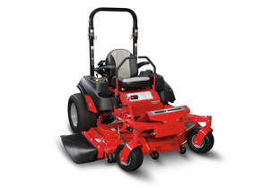  Massey Ferguson lawn mower | 1 | Massey Ferguson lawn mower mint condition  3.200$
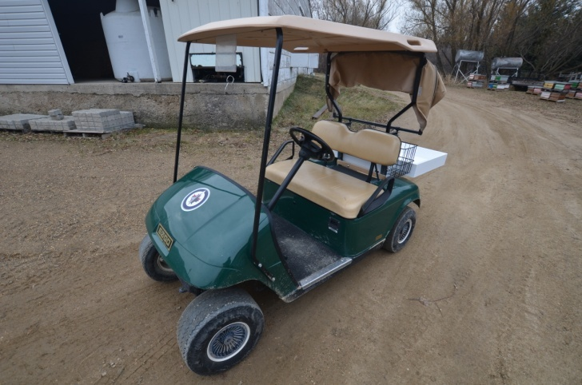  EZGO Golf kart | 1 | 2004 EZGO Golf kart well maintained  Battery changed 2 years ago, sits in a heated shelter during the winter.  Works very well  1.500$
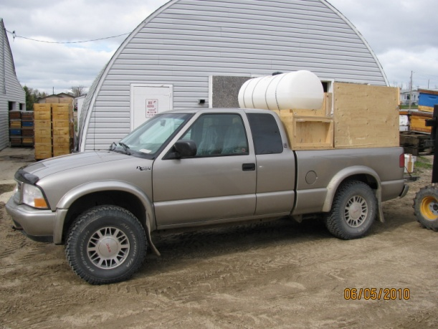  2000 GMC SONOMA | 1 | GMC Sonoma 4X4  4.500$
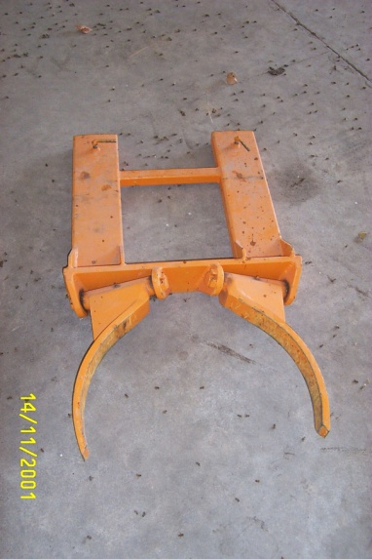  Barrel kart | 1 | Drum grabber  400$
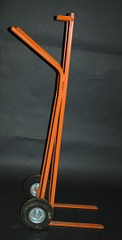  Super cart | 2 | 200$ each
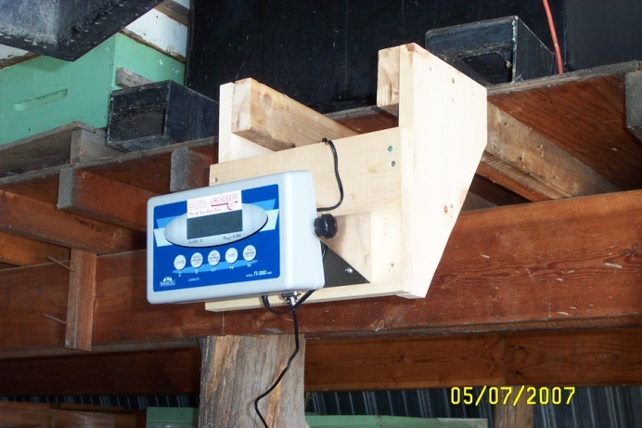  2000 lbs scale | 1 | High precision 2000 lbs scale to weight the honey drums.  1.500$
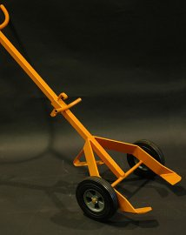  Barrel cart | 2 | 400$ each
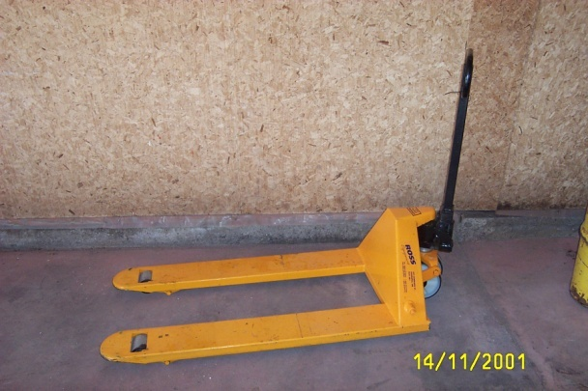  Ross equipment pallet jack | 1 | 250$, works very well
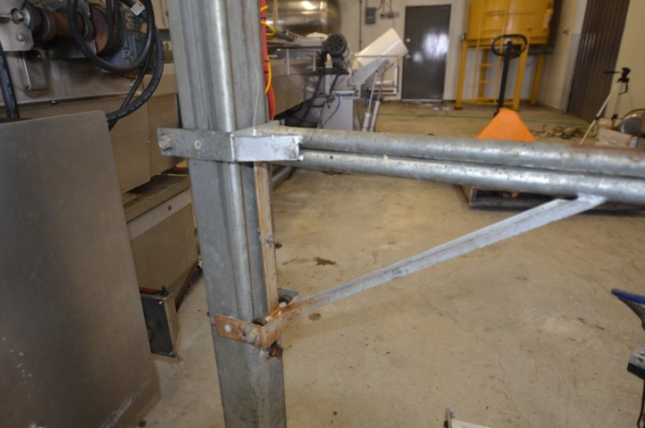  Bachelo lift | 1 | Bachelo lift  Comes with 8 frame grabber  2.500$  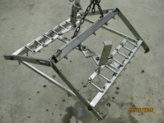
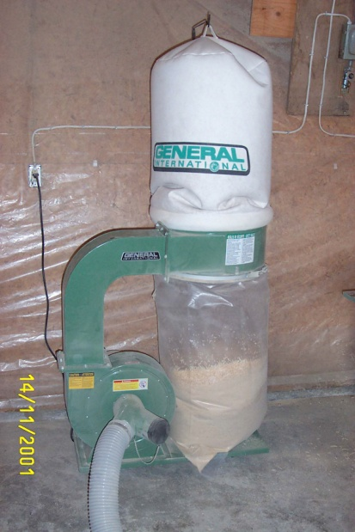  GI dust collector | 1 | Dust collector  500$
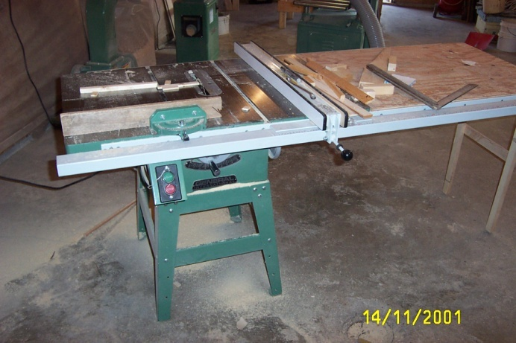  GI Table saw contractor style | 1 | GI table saw contractor style  Comes with an extension for the table and a glide fence.  1.250$
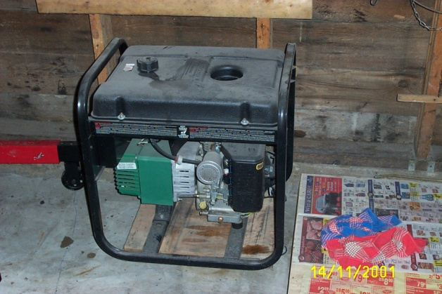  5000 watts Powermate generator | 1 | 750$
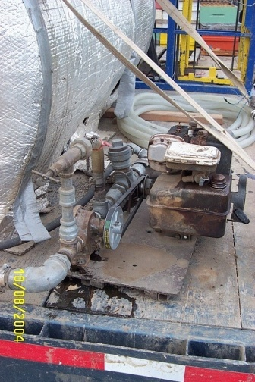  Syrup pump | 1 | Syrup pump  500$
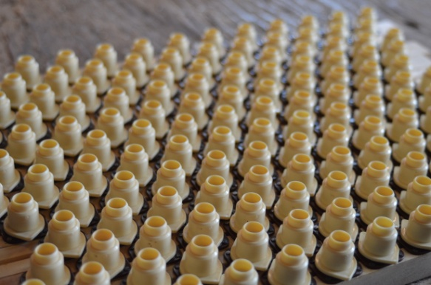  Rearing equipment | 1 | Full set of rearing equipment  Thousands of plastic cells, cup holders, cup sockets mounted on grafting frames, china grafting tools,hundreds of queens cages, Hair roller queen cages, queen protectors, all you need for grafting and rearing your own queens. Magnifying glasses and more.  1.000 $
50 double 4 frame matting nucs with integrated feeder | 50 | Brand new wood matting nucs.  Never used, custom made by myself. all painted different colors. Very strong construction.  30$ each Could send the picture on demand
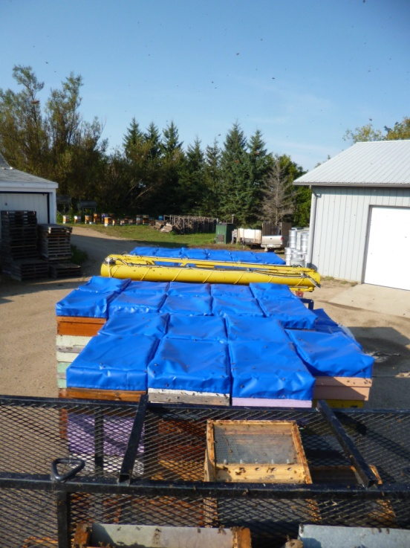  Anti robbing wraps | 50 | Anti robbings mats. every single wraps is equipped with a small stretch cords that allows you to keep your boxes bee tight, no robbing anymore at the end of the season  15$ each
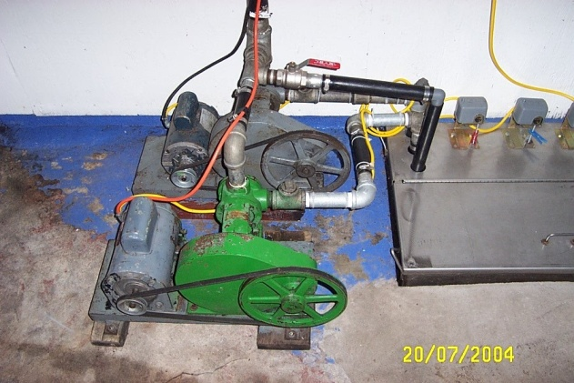  viking pumps | 2 | 1 inc 1/4 viking pumps  Picture is not up to date.  Pumps have been restaured since then and all fittings are in stainless.  1000$ each
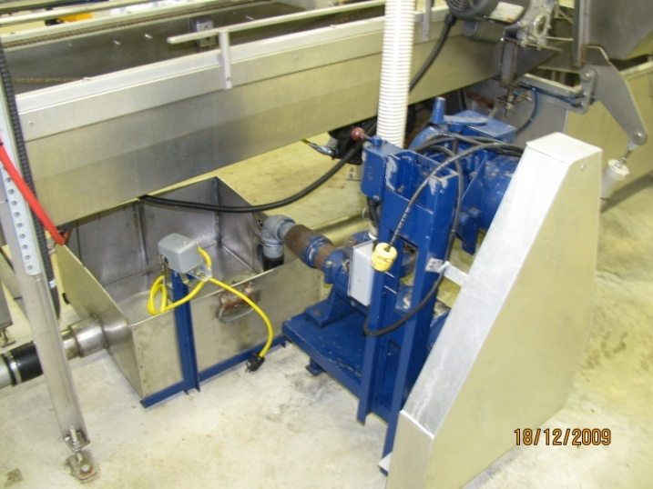  2 inch Moino pump | 1 | This pump is indestructible.  The electric motor has been changed recently and all gaskets replaced last year. This pump is in great condition and works like a charm.  3.500$
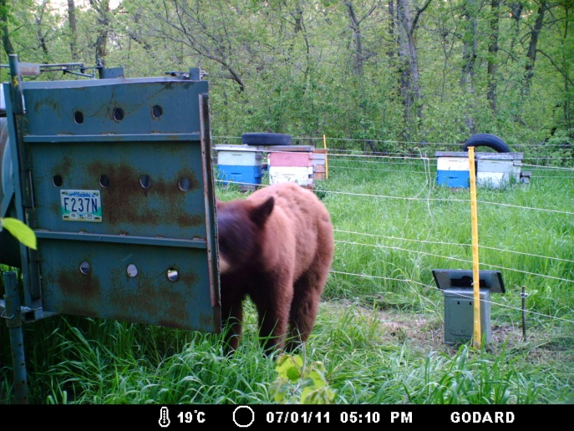  Bear fences | 3 | 3 set of bear fence with many posts and tons of cable  350$ each

